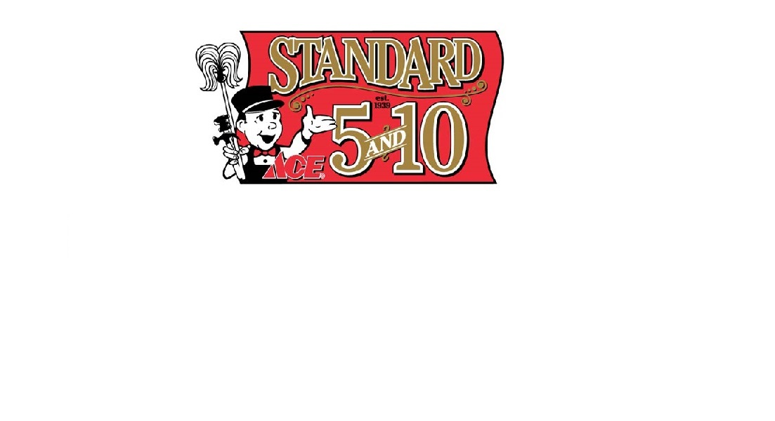
FACT SHEET


STANDARD 5 & 10 ACE
“Your One-Stop Variety Store” -- Since 1939!
Standard 5 & 10 offers thousands of products at everyday low prices and old-fashioned customer service, making us your one-stop variety store in San Francisco’s Laurel Village!
PRODUCTs:
We carry over 25,000 items in a variety of categories, including:

- cleaning supplies
- paints & glues
- tools and sanding abrasives
- electrical and lighting
- batteries
- hardware
- plumbing and electrical
- housewares and appliances
- Weber BBQs
- outdoor living
- live plants and garden items
- stationery and party goods,
- Hallmark products
- gifts
- candy and snacks
- dry goods, notions
- health & beauty aids
- toys
- seasonal items
- postage stamps

Standard 5 & 10 is "Your One-Stop Variety Store!" - since 1939!

Services:
- Ace Rewards frequent shopper program
- Special orders of thousands of items, shipped here in a few days at no extra charge
- Monday 55+ Senior Special 10% Discount
- Complete paint services including color-matching
- Knife sharpening services
- Postage stamps
- Key duplicating (including most chip keys)
- Helium balloons
- ATM access ($100.00 cash back)
- Watch Service/Battery Replacements
- Free gift wrapping with $10.00 minimum purchase
- Free delivery in our delivery area (no amount too small/too big)
- Assembly available on BBQs, Wagons/Trikes, etc.
- $50 flat charge for BBQ assembly, delivery anywhere in SF or Marin County, and removal of your old grill
- No-hassle return policy -- your receipt guarantees that we’ll fix it, exchange it, or return your money, no questions asked!
- Online ordering at AceHardware.com – select “ship to store” and pay no shipping charges when you pick up your order at Standard 5&10 Ace

Services cont’d:
- Best buys and incredible bargains
- Standard 5&10 Ace/Marin Ace NEWS, a quarterly newsletter with store news and helpful hints
- Standard 5&10 Email newsletter
- Personal Shopper Services
- Corporate Accounts for companies in the SF Bay Area
- Commercial Accounts to purchase Office Supplies
- Customer Accounts for property owners and building managers

STANDARD 5 & 10 ACE
"Your One-Stop Variety Store" Since 1939!
Family-owned and operated, offering solutions to your projects for 75 years.

Owners: Jeff & Michelle Leopold

STORE LOCATION
Laurel Village Shopping Center
3545 California Street between Laurel & Spruce
San Francisco, California 94118
FREE PARKING at rear of store (Metered parking in front)
STORE HOURS
Monday through Friday 8:30 AM to 7:00 PM
Saturday and Sunday 9:00 AM to 6:00 PM
Holiday hours may vary
Closed Thanksgiving, Christmas, and New Year’s Day.

contact us:
Phone 415/751-5767
Fax 415/213-0364
e-mail:info@standard5n10.com
website www.standard5n10.com
Find Standard 5&10 Ace on Facebook, Twitter, and Flickr
Sign up for monthly mobile-only offers by texting STANDARD to 55155
Follow us on Pinterest (as Stan Standard)

Updated 4/28/14

Contact:
Michelle Leopold, Owner/Marketing & Charitable Contributions
415/302-4055 cell
marketing@standard5n10.com

