HELPING YOU is our #1 job every day!
And – did you know about these extra services we offer
at Marin Ace, Laurel Ace, and Standard 5&10 Ace?

We offer these helpful services at our stores:
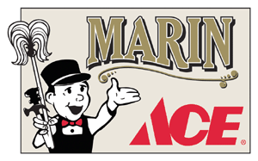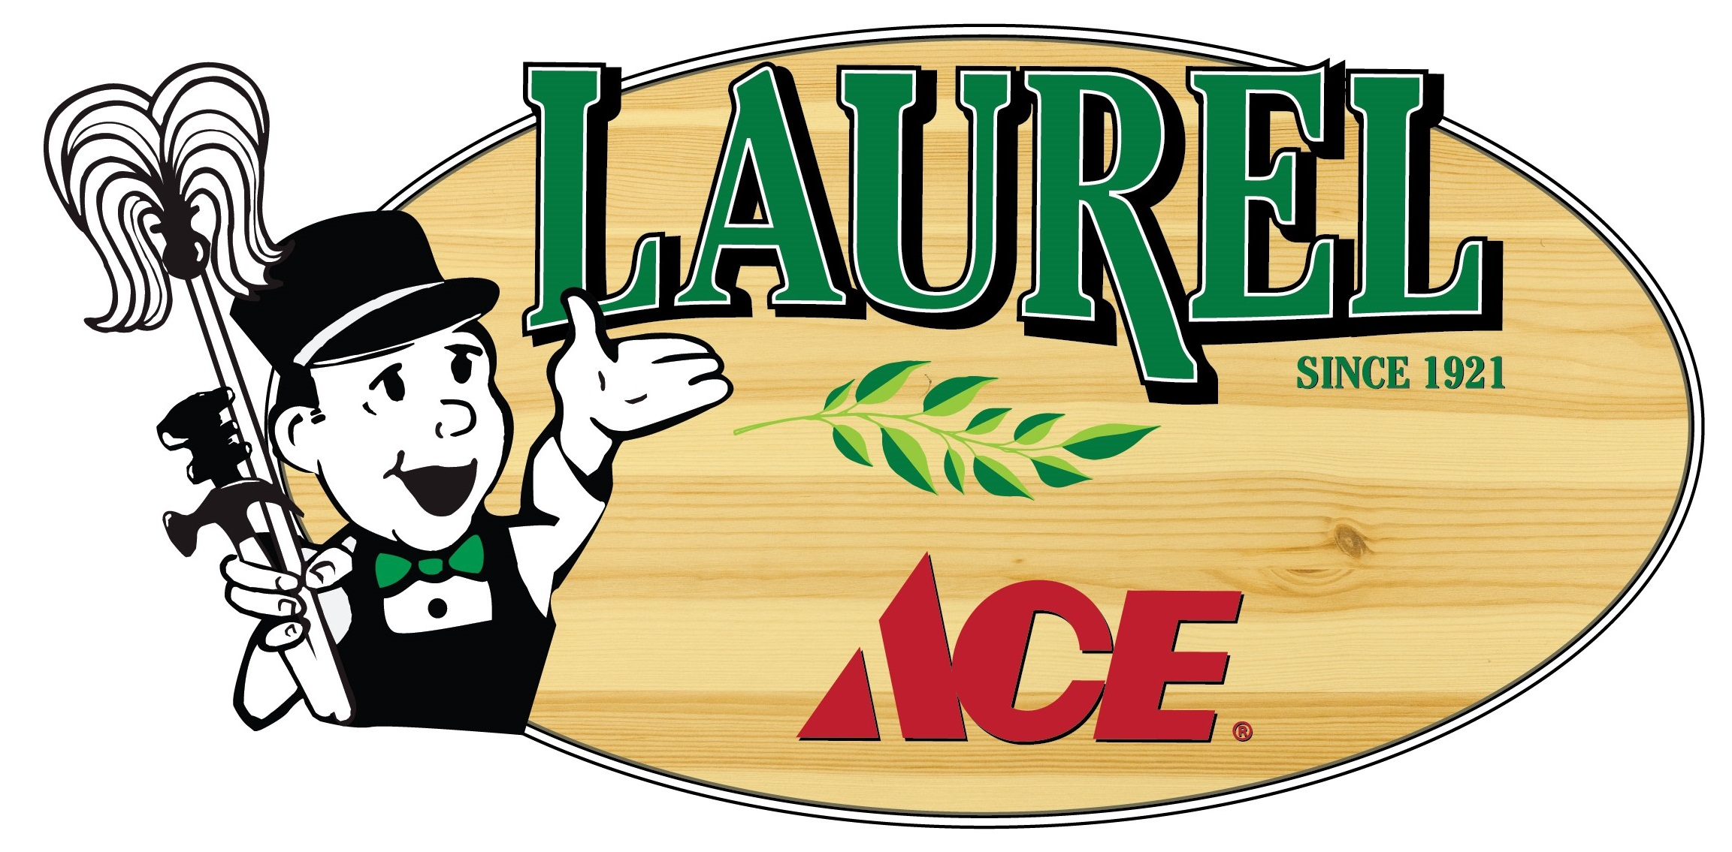
X | X | X | Ace Hardware items: thousands in stock & more on special-order
X | X | X | Ace Rewards, our frequent shopper program – rebates and more!
X | X | X | Assembly available on most items for a nominal fee
X | X | X | ATM access ($100.00 cash back)
X | X | X | B2B Corporate Accounts for all sizes of companies
X | X | X | Carry-out service available
X | X | X | Charitable contributions considered (mail requests)
X | X | X | Charge Accounts available
X | X | X | Credit cards accepted
X | X | X | Free email and snail mail newsletter
X | X | X | Delivery available
X | X | X | Free Parking in our large parking lot
X | X | X | Gift Cards available
X | X | X | Green Products: look for the “helpful earth choices” signs throughout the store
X | X | X | Key duplicating, including most Chip Keys and Key Fobs
X | X | X | Made in the USA: look for American-made signs throughout the store
X | X | X | Military Discount – 10% off year-round with current military ID
X | X | X | No-hassle return policy -- your receipt guarantees that we’ll fix it, exchange it, or return your money within 30 days of purchase, *no questions asked! *
X | X | X | Online shopping at AceHardware.com, free delivery when you choose “pick up at store”, online inventory allows you to pick up many items the same day!
X | X | X | Paint color matching
X | X | X | Price Match Guarantee
X | X | X | Propane tank exchange program
X | X | X | Recycle your household batteries, CFLs, fluorescent tubes, and American Flags here
X | X | X | Senior Discount Day - Monday 55+ receive 10% off
X | X | X | Sodastream canister exchanges
X | X | X | Special orders always welcome, including over 250,000 ACE hardware items shipped here in a few days at no extra charge
X | X | X | Watch Batteries
X |  | X | Neonicotinoid-Free Plants and Seeds – to help protect our pollinators!
X |  | X | Sharpening service for tools and knives
X |  |  | Lock Servicing
X |  |  | Popcorn machine popping weekly, available for your charitable events
X | X |  | Rug Doctor carpet cleaning rentals
 | X |  | Glass Cutting
 | X |  | Pipes cut and rethreaded
 | X |  | Screen Repairs and rescreening
 |  | X | Clipper Card purchases and reloads
 |  | X | Free gift wrapping on items $20.00+
 |  | X | Free delivery by appointment to our local delivery area
 |  | X | Helium balloons
 |  | X | Parking Cards available for SF parking meters
 |  | X | Stamps (face value for Ace Rewards members)
SR | OAK | SF
Let us know how we can help you with your projects!
Locally owned and operated, now three stores offering solutions to our neighbors in San Rafael, Oakland, and San Francisco.

